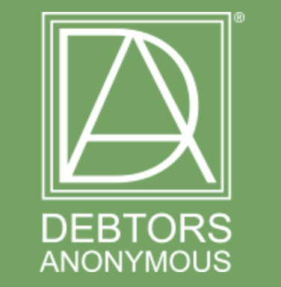

Fellowship Wide Call
SATURDAY, JUNE 1ST 2024
10-11:30 AM PACIFIC
1-2:30 PM EASTERN
6-7:30 PM BST

Presented by:
THE WSC SPIRITUALLY SUSTAINABLE EARNING CAUCUS

Spiritually Sustainable Earning is earning that meets our emotional, mental, physical, and spiritual needs. As we work the Steps and apply the Tools in everything we do, our earning efforts come into alignment with our Higher Power’s will. As a result, we find ourselves living a prosperous life, wealthy in relationships and rich in experiences.

Please join us to hear from three D.A. members how spiritually sustainable earning has changed their lives.

The qualifications will be followed by Q & A / Open Sharing.

USA & CANADA CALL IN NUMBER: +1.605.472.5540
ACCESS CODE: 617093
For international numbers and online access:
www.debtorsanonymous.org/call-in-access

